COLLEGE OF APPLIED SCIENCE

(Affiliated to University of Kerala, Managed by IHRD)

Adoor, Kerala



Project Report

On

SMART CITY

Submitted in partial fulfillment of the requirements

For the award of the degree of BSc Computer Science of

University of Kerala

**Presented by**

AKHILA S PILLAI

AlFIYA NIZAm

Sarath s sivanandan

sneha anna samuel

College of Applied Science

(Affiliated to university of Kerala, Managed by IHRD)

*Adoor, Kerala*

**

Certificate

This is to Certify that the project work entitled **“SMART CITY**” has been carried out by **Akhila S Pillai** (32018802007), **Alfiya Nizam**(320188020011), **Sarath S Sivanandan** (32018802038) and **Sneha Anna Samuel**(32018802040) of 6th semester BSc Computer Science from 2018-2021

*Project Coordinator External Examiner*

# C:\Users\DELL\Desktop\emp.png

# INSTITUTE OF HUMAN RESOURCES DEVELOPMENT

**(Established by the Government of Kerala)**

* 1. PT

**CENTRE FOR ACADEMIC PROJECT AND TRAINING** *Phone: 04734-224076*

College of Applied Science Adoor Campus Adoor .P.O, Pathanamthitta (Dist)

Kerala-691523

*This is to certify that the following students of* ***College of Applied Science, Adoor*** *has successfully completed the project entitled* ***“ Smart City ”*** *at* ***C-APT****(CENTRE FOR ACADEMIC PROJECT AND TRAINING) during the year* ***2020-21*** *in partial fulfillment of the requirements for the award of* ***BSc Computer Science*** *from* ***Kerala University*** *.*

* + 1. **Akhila S Pillai**
    2. **Alfiya Nizam**
    3. **Sarath S Sivanandhan**
    4. **Sneha Anna Samuel**

*Project Supervisor Co-ordinator*

*Date:****13/07/2021***

**ACKNOWLEDGEMENT**

The success and final outcome of this project required a lot of guidance and assistance from many people and we are extremely privileged that we have got this all along the completion of our project. All that we have done is only due to such supervision and assistance and we would not forget to thank them.

Werespectandthank  *Mrs. LATHA P,* forprovidinguswiththe opportunity to do the project work in COLLEGE OF APPLIED SCIENCE, ADOOR and giving us all support and guidance which made me complete the project duly. I am extremelythankful *to* for providing such a nice support and guidance, although he had busy schedul*e* managingthecorporateaffairs.

 I heartily thank our internal project guide, Mr. AJAYAKUMAR T ,Head Of the Department for his/her guidance and suggestions during this project work

 We owe our deepest gratitude to our project guide Mrs. CHINCHU, ASST.PROFESSOR, computer science department, who took keen interest on our project work and guided us all along, till the completion of our project work by providing all the necessary information for developing a good system.

 I heartily thank our internal project guide, Mrs. SHARI, ASST.PROFESSOR, Mrs. SARANYA S ,ASST PROFESSOR computer science department for her/his guidance and suggestions during this project work

 I am thankful to and fortunate enough to get constant encouragement, support and guidance from all Teaching staffs of computer science departmentandourfriends which helped us in successful*ly* completingourprojectwork*.*

No words can express our humble and eternal gratitude to our beloved parents and relatives who have been guiding us in everything in our life.

*Above all thank GOD ALMIGHTY for helping us in completing this project.*

AKHILA S PILLAI

ALFIYA NIZAM

SARATH S SIVANANDAN

SNEHA ANNA SAMUEL

**ABSTRACT**

**Smart City**project is an essential whenever we are visiting a particular city. It gives us the valuable information about the city and saves the time. Our project laid a web based platform for the city guide and can search every place in the city without taking the help of any personal guide. You can search a city for its prominent places of the city user, and can get social and political information of the city, city culture, security, entertainment, Business, Hotels, sightseeing places, route map etc. This site provides the details regarding the hotels, hospitals, restaurants and their specialties. I.e. this site helps to find specialists in a city along with route map.

**CONTENTS**

**TITLE**

**PAGE NO:**

**1.Introduction…………………………………………… 6**

1.1 Project and Overview 7

1.2 Objective 7

**2.System Analysis………………………………………... 8**

2.1 Introduction 9

2.2Existing System 9

2.3 Proposed System 10

2.4 Feasibility Study 11

2.5 Use Case Diagram 13

2.6 Data Flow Diagram 17

**3.System Environment…………………………………. 20**

3.1 Introduction 21

3.2 Hardware Specification 21

3.3 Software Specification 21

3.4 Development Tools 22

**4.System Design……………………………………………. 25**

4.1 Introduction 26

4.2 Process Design 26

4.3 Database Design 27

4.4 User Interface Design 32

**5.Coding……………………………………………………….. 35**

5.1 Introduction 36

**6.System Testing………………………………………………. 40**

6.1 Introduction 41

6.2 Testing Strategies 41

6.3 Unit Testing 41

6.4 Integration Testing 41

6.5 Validation Testing 41

**7.System Implementation……………………………………….. 42**

**8.Future Enhancement………………………………………….. 44**

**9.Conclusion……………………………………………………… 46**

**10.Bibliography……………………………………………………. 48**

**11.Appendix…………………………………………………………. 50**

**1.INTRODUCTION**

**1.1 Project an Overview**

Everyday a large number of people are coming to all the cities seeking job, higher studies, business, tourism, etc. Initially all the system of the city are unknown to the new comers of the city. They don’t know much about institutions etc. But implementation of Smart City Project provides the complete solution package for new comers.

The use of internet is rapidly growing in all cities around the globe. Nowadays, people prefer searching in internet to enquiring the locals of the city. The smart city web pages can be browsed from anywhere using internet service and all the details of the city can be accessed. One can see all the necessary information about city through this online application.

**Smart City**project is an essential whenever we are visiting a particular city. It gives us the valuable information about the city and saves the time. Our project laid a web based platform for the city guide and can search every place in the city without taking the help of any personal guide. You can search a city for its prominent places of the city user, and can get social and political information of the city, city culture, security, entertainment, Business, Hotels, sightseeing places, route map etc. This site provides the details regarding the hotels, hospitals, restaurants and their specialties. I.e. this site helps to find specialists in a city along with route map.

Here,

* Registered user can book their rooms
* Route Map is available

**1.2 OBJECTIVES**

* To computerize all details of hotels, education institution, company, bank, details and users details.
* The information of the city should be kept up to date and there record should kept in the system for historical purposes.
* To provide faster and efficient manipulation of city details.
* Less effort and easy to manage.
* User friendly. Saves Time.

**2. SYSTEM ANALYSIS**

**2.1 INTRODUCTION**

In this phase the existing system is studied thoroughly which helps to know its requirements and nature. Depending upon this study the further steps for developing the system can be identified. But we have manual existing system. So we studied about the requirements and collect data manually.

**2.2 Existing System**

The existing system uses manual method for the whole process such manual entry of details .This requires a lot of hard work and time consumption to complete the task. This may include human errors. In the existing system, it is difficult to retrieve some particular information. Also, all the records are stored manually and it is a tedious task. As a result the security of these records is always a challenging task.

**Limitations of existing system**

* Not reliable
* The data are stored in different books
* The search operations are not effective
* Time consuming
* Records are kept by hard copy

**2.3 PROPOSED SYSTEM**

The proposed system is interactive, highly user friendly and designed exclusively for the “Smart City”, product details, sellers and buyers details. The system covers almost all the functional areas of the “E-Augeo” such as tourist spot, hospitals, feedback & suggestion, etc.

All the operations and activities related to the “Smart City” can be carried out efficiently. The project maintains well organized database for storing the resources that they are provided by the client. This helps us to eliminate the entering of invalid data. Most problems of manual system can be solved by this system.

The computerization of the system allows the easy maintenance of the details. Large amount of data can be stored easily. Addition and updating other changes can be done easily. The information can be retrieved with high speed and accuracy. The use of GUI oriented software makes the system user friendly. Since all work is computerized, the calculations are effortless and less time consuming. Speed, accuracy, storage capacity, versatility, automation etc. are the advantages of using a computerized system.

The main purpose behind the proposed system is to provide a comprehensive computerized system, which can capture, collate and analyze the data from these wards and evaluate the impact of the program.

**Advantages**

* User friendly
* Interaction became easier.
* Provide security and privacy for the data.
* Reduce manual effort.
* Reducing the processing time.
* Online booking facility for registered users.
* Computerized prescribing.

**2.4 Feasibility Study**

Feasibility study is a test of system proposals according to its workability, ability to meet the needs and effective use of resources.

**Operational Feasibility**

The operational feasibility mainly related to operational scope of the software to be developed. It also focus on what changes will be bought to the system.

Almost everyone is aware of using internet and computer. This software is operationally feasible as it is very easy for the end users to operate it. The basic knowledge of computer and internet usage are needed.

**Technical Feasibility**

It is the study of resource availability that may affect the ability to achieve an acceptable system. This evaluation determines whether the technology needed for the proposed system is available or not. Here the levels of technology consist of the programming language, the hardware resources, other software tools etc. Hence it is technically feasible. The developed system has least technical requirement as only minimal or null changes are required for implementing the system.

Almost all houses in Kerala have computer . It also has a broadband internet connection. As these facilities are enough for implementing the software. So this is technically feasible.

**Economic Feasibility**

It is considered as the final stage of most of the system. It includes a broad range of concerns that includes cost benefit analysis.

This software is economically feasible to users and companies. As the houses already possess the machines, technical systems need not invest more money. Once the project is installed and started working smoothly, the companies can even reduce the manpower in the office which will help the companies office to cut down their establishment cost. Stationary cost also will be reduced. The users need not visit the companies to get the service. If they are employed they don’t want to lose a working day. Thus the project economically feasible to users also. Even if they don’t have a computer they can access the services from nearby computer centre very cheaply. Thus the project is economically feasible.

**2.5 Use case diagram**

A Use case is a set of scenarios that describing an interaction between a user and a system. A use case diagram displays the relationship among actors and use cases. The two main components of a use case diagram are use case and actors.

Use Case Actor

An actor represents a user or another system that will interact with the system we are modeling. A use case is an external view of the system that represents some action the user might perform in order to complete a task.

A use case diagram is used in almost in every project. They are helpful in exposing requirements and planning the project. During initial stage of a project most cases should be defined but as the project continues more might become visible.

**Use Case diagram for Admin**

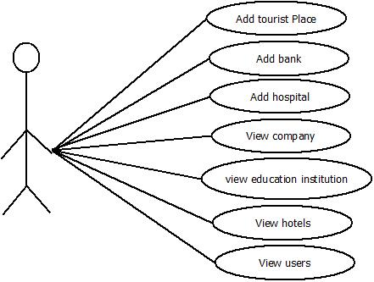

**ADMIN**

* **Use Case diagram for Hotel**

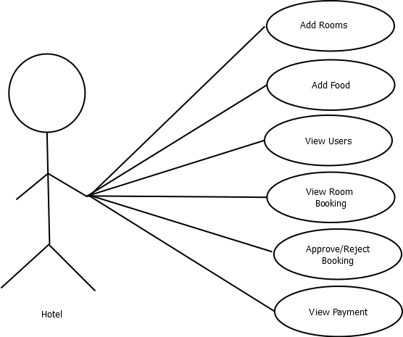

* **Use Case diagram for education institution**

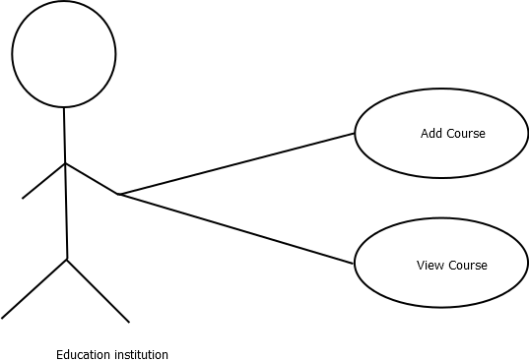

* **Use Case diagram for Company**

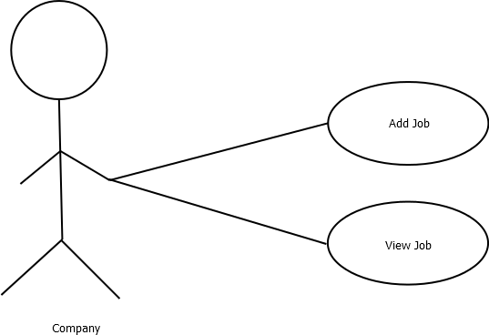

* **Use Case diagram for Users**

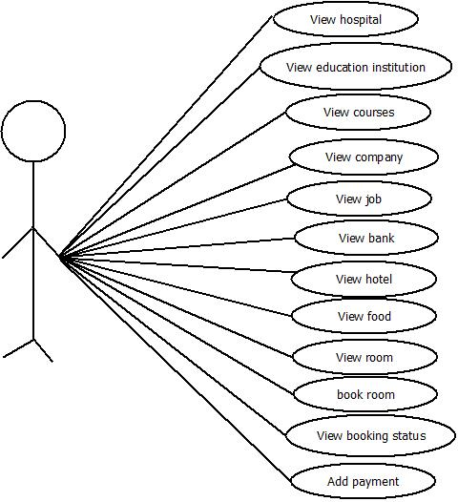

**USERS**

**2.6 Data Flow Diagrams**

The main merit of data flow diagram is that it can provide an overview of what data a system would process, what transformation of data are done, what files used and where the result flow. Four symbols are used in drawing data flow diagram.

A circle is used to depict a process. Both inputs and outputs are data flows.

A line with arrow represents data flows. The arrow shows the direction of flow.

External entities are represented by rectangles. Entities supplying data are known as sources and those that customer data are called links.

An open rectangle is used to store data.

**LEVEL 0 DFD**

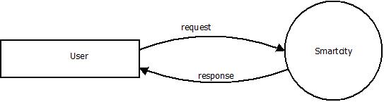

**LEVEL 1 DFD**

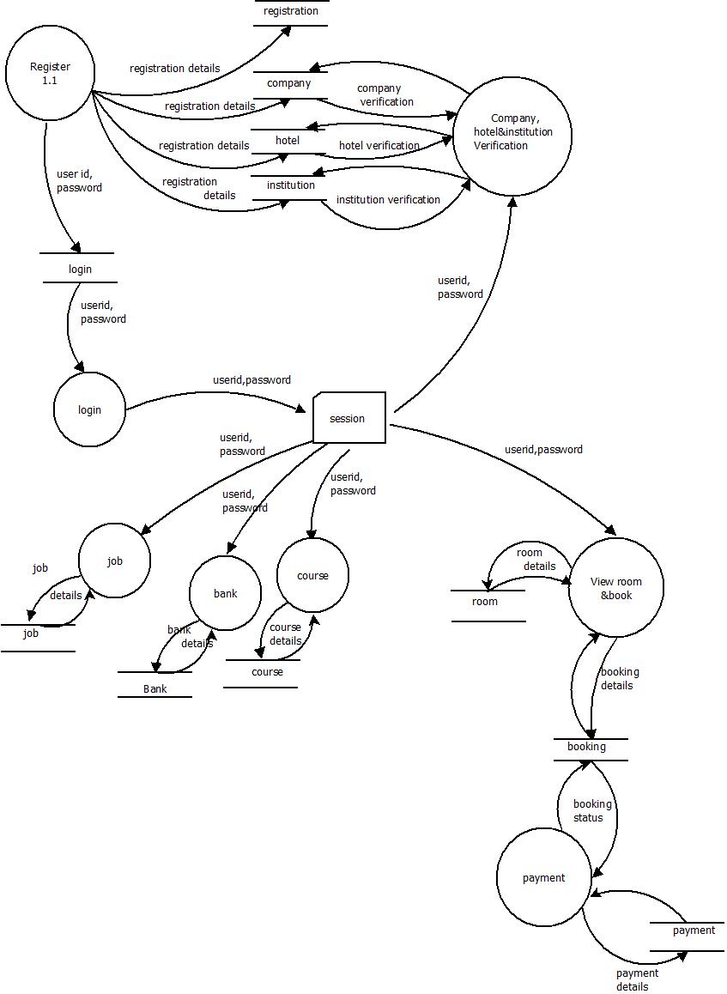

**3.SYSTEM ENVIRONMENT**

**3.1 Introduction**

The requirement specification focuses on the infrastructure, hardware and software requirements for developing the system. Infrastructure is basic physical and organizational structures needed for the operation of a society or enterprise, or the services and facilities necessary for an economy to function. It can be generally defined as the set of interconnected structural elements that provide framework supporting an entire structure of development. The infrastructure requirement specifies what are the needs of the system to use this software. The infrastructure requirements of this system include a PC with net connection.

**3.2 Hardware Specification**

**Server requirements**

The web server can be implemented in a rented space. However the optimum requirements for a separate server machine to install and run the portal is given below.

Processor : Intel Duo

Hard disk drive : SCSI system boot drive, 500GB

Memory : 4GB which is sufficient to handle requests from 500 concurrent users

**Client requirements**

Any PC with internet connectivity will serve the client side operations.

**3.3 Software Specification**

**Server requirements**

Operating System : Windows 8 or later

Database : MYSQL  
Web server : Apache Servers

Browser : Google Chrome/Internet Explorer

Other : PHP

**Client requirements**

Any PC with internet connectivity will serve the client side operation.

**3.4 DEVELOPMENT TOOLS**

**Coding Tools**

**PHP (Hypertext Pre-processor)**

PHP, which stands for **"**H**ypertext** P**reprocessor"**, is a server-side, HTML embedded scripting language used to create dynamic Web pages. Much of its syntax is borrowed from C, Java and Perl with some unique features thrown in. The goal of the language is to allow Web developers to write dynamically generated pages quickly.

PHP is open free software. In its newest version PHP5 strives to give something many users wanted for the past years, a much improved object-oriented programming functionality. New PHP version’s newly rebuilt object model brings PHP in line with Java, C++ offering support for features like overloading, interfaces, private member variables and methods and other OOP constructions.

PHP is easy to learn similar to other languages of the same use. PHP has a simple syntax that is quite easy to parse and human friendly. PHP is steady to solve problems today. Many of the useful functions like opening an Oracle data base and fetching email from an IMAP server are predefined for you. You can use WYSIWIG editors to design sites, format pages, insert client-side features before you add PHP functionality to the source code.

In an HTML page, PHP code is enclosed within special PHP tags. When a visitor opens the page, the server processes the PHP code and then sends the output (not the PHP code itself) to the visitor's browser. It means that, unlike JavaScript, you don't have to worry that someone can steal your PHP script.

PHP offers excellent connectivity to many databases including MySQL, Informix, Oracle, Sybase, Solid, Postgre SQL, and Generic ODBC. The popular PHP-MySQL combination (both are open-source products) is available on almost every UNIX host. Being web-oriented, PHP also contains all the functions to do things on the Internet - connecting to remote servers, checking email via POP3 or IMAP, url encoding, setting cookies, redirecting, etc.

PHP is a rather simple language. Much of its syntax is borrowed from C except for dealing with the types of variables. You don't need to think of the types of variables at all - you just work with their values, not their types. And you don't have to declare variables before you use them.

PHP is a real programming language with a bunch of predefined tags. You can define functions just by typing a name and definition. You can also use tags developed by other users in your program.

**Database Management**

**MYSQL**

MySQL (pronounced "My ess cue el") is an open source Relational Database Management System that uses Structured Query Language. Information is stored in "Tables" which can be thought of as the equivalent of Excel spreadsheets. A single MySQL database can contain many tables at once and store thousands of individual records. It's fast, reliable and flexible. We can copy MySQL to our PCs and Laptops

PHPand MySQL work extremely well together.MySQL is one of the easiest data bases to administrators on all platforms. And because it is so light weight, it can run on even low powered PCs. Databases are generally useful arguably the most consistent family of software products. Unlike other databases its administration is very simple and handy.

MySQL 4 version has introduced some innovation and changes both on the database side and PHP side.

Earlier versions of the MYSQL lacked some core SQL constructs such as sub selects and foreign keys. But because of simple licensing nature it become popular among users. MYSQL tables are of type called MyISAM. The new version of the MYSQL created new types of transaction safe table InnoDB and BDB. They impose little over head and slower in action. MySQL allows you to grant quite fine-grained permission to different users from different client locations. There are four descending levels of privileges global, database, table and column.

PHP My Admin is a web based GUI front end for the My SQL.It is the most popular The major problem available with My SQL. Is does not make MYSQL‘s security any easier to understand. The most common method of enhancing security is to use PHP My Admins’s http or cookie auth schemes. This requires creation of new PHP My Admin user who can read MySQL grant tables as well as your normal database administrator user. You can create databases with MYSQL by using the create table command. There are a number of datatype and functions available with MYSQL..PHP’s MYSQL and MYSQL improved versions are easy to use, interaction should have a connection, a database select and query or command that returns a result identifier.

**4.SYSTEM DESIGN**

**4.1 Introduction**

In system analysis, the problem is identified, alternative solutions are evaluated and the most feasible solutions are recommended. An initial investigation is performed to identify the current problems and solutions for the smooth functioning of the organization. Each module thoroughly studied and all the recommends for the project that are needed in order to satisfy the goals of the project are gathered. The problem is split into modules and is viewed at various angles. This leads to the evolution of the project. The system design should be approached like a building block. The main system has different subsystem. The identification of different modules and subsystem are the main activity during the system design. It includes input and output requirements.

**4.2 PROCESS DESIGN**

The main users of the system are Administrator, users, company, hotel, education institution.

**1 Administrator**

The site manager has the administrative power. Administrator has complete control of all the levels in the system. He can add or delete the information in the system.

**2 Users**

* View the hotels, company, education institution, bank, course, job etc details.
* View rooms and book and also view the booking status.
* Add payments, feedback

**3 Company:**

* New registration.
* Add job details.

**4 Hotel:**

* New registration
* Add room details.
* Add food details.
* View room bookings
* .view payment

**5 Education Institution:**

* New registration
* Add course details.

**4.3 Database Design**

Database design is recognized as a standard of management information system and is available virtually for every computer system. The general theme behind a database is to integrate all the information .A database is an integrated collection of data and provides centralized access to the data.

A database is a collection of interrelated data stored with minimum redundancy to serve many users quickly and effectively. The general objective of database is to make the data access easy, inexpensive and flexible the user .The main objective of designing a database are ,Data integration, Data Integrity and Data Independence.

In the database, all the information is stored in the form of tables. A table is simply a way of storing data in rows and columns. In the system the data is stored in many tables. The name of the database is “smartcity”. It contains mainly 15 tables.

**Data Records**

In the structure of a database, the part consisting of several uniquely named components called data fields. Several data records make up a data file and several data file makeup a database.

**Table Structure**

Table Name : Loginn

Description : This table contains login details.

foreign key : uid

|  |  |  |  |
| --- | --- | --- | --- |
| Field name | Data type | Constraints | Description |
| Uid | Int(20) | Foreign key | User id |
| Uname | Varchar(25) | Null | Username |
| Upass | Varchar(30) | Null | Password |
| Utype | Varchar(40) | Null | User type |
| Status | Varchar(30) | Null | Status |

Table Name : Ureg

Description : For the registration of users

Primary Key : User_id

|  |  |  |  |
| --- | --- | --- | --- |
| Field name | Data type | Constraints | Description |
| User_id | Int(10) | Primary key | User id |
| Name | varchar(20) | Null | Name |
| Address | varchar(50) | Null | Address |
| Phno | varchar(10) | Null | Phone number |
| Email | varchar(15) | Null | Email |

Table Name : companyreg

Description : For the registration of company

Primary Key : cmpid

|  |  |  |  |
| --- | --- | --- | --- |
| Field name | Data type | Constraints | Description |
| Cmpid | Int(5) | Primary key | Company id |
| Company_name | varchar(15) | Null | Company name |
| Address | Varchar(20) | Null | Address |
| Place | Varchar(50) | Null | Place |
| Pincode | varchar(10) | Null | Pincode |
| Phone_no | varchar(30) | Null | Phone number |
| License_no | varchar(7) | Null | License number |
| Registration_year | varchar(15) | Null | Registration year |
| Website | Varchar(10) | Null | Website |
| Map | varchar(15) | Null | Map |
| Email_id | varchar(50) | Null | Email id |

Table Name : hotelregister

Description : For storing hotel details

Primary Key : hid

|  |  |  |  |
| --- | --- | --- | --- |
| Field name | Data type | Constraints | Description |
| Hid | Int(10) | Primary key | Hotel id |
| Name | Varchar(40) | Null | Hotel name |
| Place | Varchar(30) | Null | Place |
| Phoneno | Varchar(13) | Null | Phone number |
| Licenseno | Varchar(10) | Null | License number |
| Website | Varchar(50) | Null | Website |
| Map | Varchar(40) | Null | Map |
| Email | Varchar(50) | Null | Email id |

Table Name : edureg

Description : For the registration of education institution

Primary Key : Eid

|  |  |  |  |
| --- | --- | --- | --- |
| Field name | Data type | Constraints | Description |
| Eid | Int(5) | Primary key | Institution id |
| Institute_name | Int(10) | Foreign key | Institution name |
| Address | Varchar(10) | Primary key | Address |
| Place | Int(10) | Null | Place |
| Pincode | Varchar(7) | Null | Pin code |
| Phone_no | Varchar(20) | Null | Phone number |
| Type | Varchar (10) | Null | Type |
| University | Varchar(15) | Null | University |
| Website | Varchar(15) | Null | Website |
| Email_id | Varchar(10) | Null | Email id |

Table Name : addhospital

Description : For storing hospital details

Primary Key : Hid

|  |  |  |  |
| --- | --- | --- | --- |
| Field name | Data type | Constraints | Description |
| Hid | Int(10) | Primary key | Hospital id |
| Name | Varchar (20) | Null | Hospital name |
| Place | Varchar (100) | Null | Place |
| Phoneno | Varchar(13) | Null | Phone number |
| Emailid | Varchar(50) | Null | Email id |
| Website | Varchar(50) | Null | Website |
| Map | Varchar(40) | Null | Map |

Table Name : Addbank

Description : For store bank details

Primary Key : Id

|  |  |  |  |
| --- | --- | --- | --- |
| Field name | Data type | Constraints | Description |
| Id | Int(5) | Primary key | Bank id |
| Name | Varchar(40) | Nul | Bank name |
| Place | Varcher(40) | Null | Place |
| Phoneno | Varchar(13) | Null | Phone number |
| Emailed | Varchar(40) | Null | Email id |
| Ifsccode | Varchar(12) | Null | I f s c code |
| Website | Varchar(40) | Null | Website |
| Map | Varchar(40) | Null | Map |

Table Name : addjob

Description : For storing job details

Primary Key : Id

|  |  |  |  |
| --- | --- | --- | --- |
| Field name | Data type | Constraints | Description |
| Id | int(15) | Primary key | Job id |
| Jobname | varchar(20) | Null | Job name |
| jobcategory | Varchar(40) | Null | Job category |
| No_of_vaccancy | Varchar(10) | Null | No of vacancy |
| Qualification | Varchar(40) | Null | Qualification |
| Experience | Varchar(10) | Null | Experience |
| Endingdate | Varchar(10) | Null | Ending date |
| Vid | Varchar(10) | Null | Company id |

Table Name : coursedetails

Description : For storing course details

Primary Key : Id

|  |  |  |  |
| --- | --- | --- | --- |
| Field name | Data type | Constraints | Description |
| Id | int(15) | Primary key | Course id |
| Course | varchar(20) | Null | Course name |
| No_of_seat | Varchar(40) | Null | No of seat |
| Fees | Varchar(10) | Null | Fees |
| Year | Varchar(40) | Null | Course year |
| Vid | Varchar(10) | Null | Institution id |

Table Name : tourplace

Description : For storing tourist place details

Primary Key : Id

|  |  |  |  |
| --- | --- | --- | --- |
| Field name | Data type | Constraints | Description |
| Id | int(15) | Primary key | Tourist place id |
| Name | varchar(20) | Null | Place name |
| Description | Varchar(40) | Null | Description |
| location | Varchar(10) | Null | Location |
| Landmark | Varchar(40) | Null | Place |
| Map | Varchar(10) | Null | Map |

Table Name : roominfo

Description : For storing room details

Primary Key : Id

|  |  |  |  |
| --- | --- | --- | --- |
| Field name | Data type | Constraints | Description |
| Rid | int(15) | Primary key | Room id |
| Room_no | varchar(20) | Null | Room number |
| Room_type | Varchar(40) | Null | Room type |
| Bed_type | Varchar(10) | Null | Bed type |
| Rate | Varchar(40) | Null | Amount |
| Image | Varchar(50) | Null | Image |
| Vid | Varchar(10) | Null | Hotel id |

Table Name : foodinfo

Description : For storing food details

Primary Key : Uid

|  |  |  |  |
| --- | --- | --- | --- |
| Field name | Data type | Constraints | Description |
| Uid | int(15) | Primary key | Food id |
| Food_type | varchar(20) | Null | Food type |
| Food | Varchar(40) | Null | Food name |
| Image | Varchar(10) | Null | Image |
| Rate | Varchar(40) | Null | Amount |
| Vid | Varchar(10) | Null | Hotel id |

Table Name : roombook

Description : For storing room booking details

Primary Key : bid

|  |  |  |  |
| --- | --- | --- | --- |
| Field name | Data type | Constraints | Description |
| Bid | int(15) | Primary key | Booking id |
| Room_no | varchar(20) | Null | Room no |
| Typee | Varchar(40) | Null | Room type |
| No_of_person | Varchar(10) | Null | No of persons |
| No_of_days | Varchar(40) | Null | No of days |
| Rid | Varchar(10) | Null | Room id |
| Vid | Varchar(10) | Null | User id |
| Amt | Varchar(10) | Null | Amount |
| Tamt | Varchar(10) | Null | Total amount |
| Statuss | Varchar(30) | Null | Status |
| Hid | Varchar(10) | Null | Hotel id |

Table Name : pay

Description : For storing payment details

Primary Key : Id

|  |  |  |  |
| --- | --- | --- | --- |
| Field name | Data type | Constraints | Description |
| Id | int(15) | Primary key | Payment id |
| Amount | varchar(10) | Null | Amount |
| Card_no | Varchar(20) | Null | Card number |
| Name_of_accout_holder | Varchar(20) | Null | Account holder name |
| Cvv | Varchar(10) | Null | C v v number |
| Expiry_date | Varchar(10) | Null | Expire date |
| Paystatus | Varchar(20) | Null | Payment status |
| Vid | Varchar(10) | Null | User id |

Table Name : feedback

Description : For storing feedback details

Primary Key : Fid

|  |  |  |  |
| --- | --- | --- | --- |
| Field name | Data type | Constraints | Description |
| Fid | int(15) | Primary key | Feedback id |
| Name | varchar(20) | Null | Name |
| Feedback | Varchar(40) | Null | Feedback |

**4.4User Interface Design**

User Interfaces are simple web forms that can be operated even by a user who have no computer knowledge. In this system user interfaces are created using HTML. The system provides friendly user interfaces to do all the functions. The separate user interfaces are provided for each function. Each function can be selected by clicking the corresponding link or button. In case of data entry forms data can be entered in the corresponding text boxes or select it from the dropdown list. The functions such as add, view, remove, upload pdf etc... can be done by clicking the links.

In the case of updating, the users must update the corresponding data to update and submit it for editing his record by clicking the button

**Inputs**

There are two types of Inputs in the system. One type inputs are given by user it include various information, reports and guidelines. Other type of inputs are given by the admin itself, it includes various services like

**FORM DESIGN**

1. Home page.

Name: Home

Purpose: The purpose of this homepage is to show the details about this site. This form allows users to login and provide facilities for registration.

**LOGIN FORM**

LOGIN

Username :

Password :

FORGOT PASSWORD?

Login

**USER REGISTRATION**

USER REGISTRATION

Name :

Address : 

Phone : 

Email : 

Password : 

REGISTER

**5.CODING**

**5.1 Introduction**

The purpose of coding is to translate the software design into source code. Each component of the design is implemented as a program module. The end product of this phase is a set of program modules that have been individually tested.

**Sample Coding**

**DatabaseCon.php**

<?php

class DatabaseCon {

private $dbhost = 'localhost:3306';

private $dbuser = 'root';

private $dbpass = '';

private $conn;

function __construct()

{

// echo "inside constructor";

$this->conn = mysql_connect($this->dbhost, $this->dbuser, $this->dbpass);

if(!$this->conn )

{

die('Could not connect: ' . mysql_error());

}

//echo 'Connected successfully';

mysql_select_db( smartcity );

}

function insertQuery($qry) {

echo $qry;

$retval = mysql_query( $qry, $this->conn );

if(!$retval )

{

die('Could not enter data: ' . mysql_error());

}

//echo "Entered data successfully\n";

}

function selectQuery($str) {

// echo $str;

$f=0;

$retval=mysql_query($str,$this->conn);

$num_rows= mysql_num_rows(mysql_query($str));

//echo $num_rows;

//if(!$retval)

if($num_rows>0)

{

$f=1;

}

return $f;

}

function selectData($str)

{

$retval=mysql_query($str,$this->conn);

return $retval;

}

function updateQuery($str)

{

$retval=mysql_query($str,$this->conn);

if(!$retval)

{

die('Could not update data!'.mysql_error());

}

}

function closeDatabase()

{

mysql_close($this->conn);

}

}

?>

**Loginaction.php**

<?php

include 'DatabaseCon.php';

$db=new DatabaseCon;

$u=$_POST['t1'];

$p=$_POST['t2'];

$query="select * from loginn where Username='$u' and Upass='$p'";

echo "invalid password or username";

$ret=$db->selectQuery($query);

$rst=$db->selectData($query);

$row=mysql_fetch_array($rst);

if ($ret==1)

{

session_start();

if($row['Utype']=="admin")

{

$_SESSION['uid']=$row['uid'];

header('location:adminhome.php');

}

else if($row['Utype']=="hotel" && $row['status']=='Approve')

{

$_SESSION['uid']=$row['uid'];

header('location:hotelhome.php');

}

else if($row['Utype']=="user")

{

$_SESSION['uid']=$row['uid'];

header('location:userhome.php');

}

else if($row['Utype']=="institute" && $row['status']=='Approve')

{

$_SESSION['uid']=$row['uid'];

header('location:institutehome.php');

}

else if($row['Utype']=="company" && $row['status']=='Approve')

{

$_SESSION['uid']=$row['uid'];

header('location:companyhome.php');

}

else

{

header('location:index.php');

}

$d->closeDatabase();

}

?>

**6.SYSTEM TESTING**

**6.1 Introduction**

Software testing is critical element of software quality assurance and represents the ultimate review of specification design and coding. Testing begins by testing program modules separately followed by testing bundled modules a unit.

**Unit testing**

This is the first level of testing. A unit testing focuses verification effort on the smallest unit of software design. Testing is the process of executing a program to find bugs. Unit testing has been done during the development of each page. Unit level bugs were identified and debugged at that stage.

**System testing**

System testing actually a series of different tests whose primary purpose is to fully exercise the computer based system although each test purpose all should verify that all system have been properly integrated and perform allocated functions. System testing has been done after developing entire project. A few cases which were not taken into consideration in design phase had been identified at this stage.

**Integration Testing**

Integration testing is performed to check the correctness of the interface between the modules. The goal is to see if the modules can be integrated properly. In this project all the modules are combined and then entire program is tested as whole, thus in the integration step, all the errors uncovered for the next testing steps

**Validation Testing**

Software validation testing is an important part of the software development lifecycle (SDLC), apart from verification, debugging, and certification. Validation testing ensures that the software meets the quality standards set by the customer and that the product meets customer requirements**. Validation is determining** if the system complies with the requirements and performs functions for which it is intended and meets the organization’s goals and user needs.

**7.SYSTEM IMPLEMENTATION**

**Implementation issues**

Implementation of software refers to the final installation of the package in its real environment to the satisfaction of the intended users and the operation of the system**.**  The new system may be totally new, replacing an existing manual or automated system or it may be a modification of the existing system. A website must be popularized to gain wide use age among the common masses. In order to achieve this advertisement must be done. It should be user friendly to make it convenient to people with low computer knowledge.

**8.FUTURE ENHANCEMENT**

**Future Enhancement**

Changes in software engineering technology are indeed rapid. By the time a decision is made to adopt a new method, conduct, the training necessary to understand its application and introduce the technology into the software development culture, something new and better has come along ,and the process begins. we can develop this software to any other web applications. The Smart City satisfies the requirements of the companies providing job and eases the recruitment examination process. The system is developed in a user friendly manner. It has two module for manipulating the database. The application can be enhanced in the future with the needs of the management. The database and the information can be updated to the latest coming versions. There are also possibilities for enhancing and further developing the project with the latest information and needs of the management, since the coding are in procedural block formats, altering the code is also made easy. The efficiency of the developed system can be improved by modification. Today most of the services are based on mobile applications. This system can also be converted to apps. We can include face to face interview through video calling ion scheduled date in future.

**9.CONCLUSION**

This chapter contains the testing procedures and their principles. Testing is done after developing the system. Independent module testing is done at the beginning stage and then integrated all the tested modules, It is used to identify the possible errors that may occur and to resolve it. The project SMARTCITY is developed in PHP as front-end and MYSQL as back end in Windows Operating System We hope the SMART CITY fulfills all the needs in possible manner. The system has been developed in an interactive manner; the reports generated by the system are clear and legible. The system is flexible, user friendly and has its own full data security and all data recovery facility.

**10.BIBLIOGRAPHY**

**Bibliography**

1. PHP: The complete reference by Steven Holzner

1. Elias.M.Award. (1991)’System Analysissign’, Galgotia Publication Pvt.Ltd.
2. .Roger.S.Pressman.(1991)’SoftwareEngineering’,McGraw-HillEditions.
3. . Beginning PHP and MySQL.5 from Novice to ProfessionalEdition, W.Jason Gilmor
4. Head First PHP & MYSQL by Lynn Beighley, Michael Morrison
5. Tutorial points
6. W3schools.

**11.APPENDIX**

**MAIN FORMS**

USER REGISTRATION FORM

­­­ 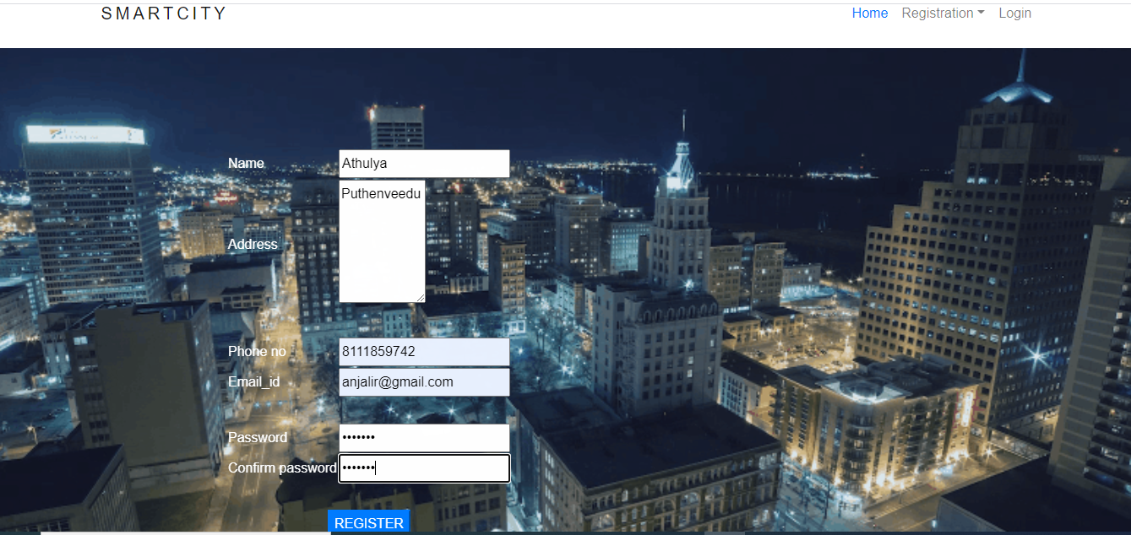

HOTEL REGISTRATION FORM

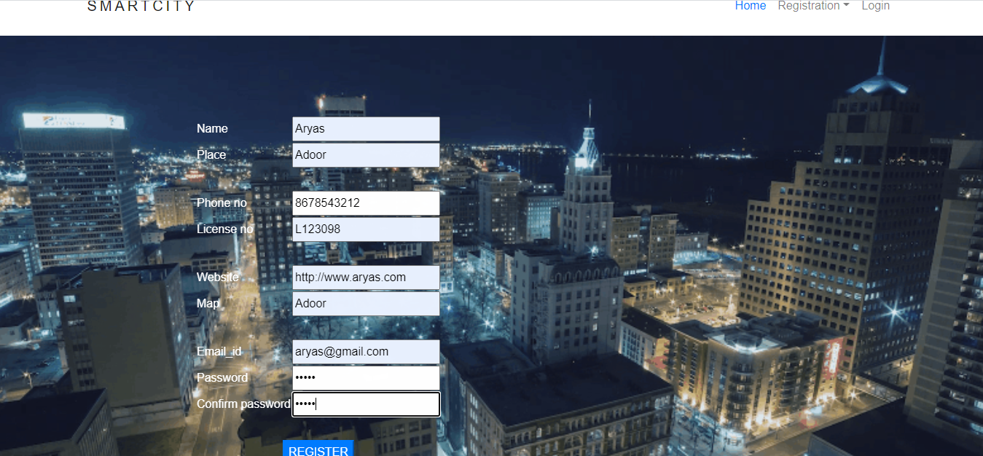

COMPANY REGISTRATION

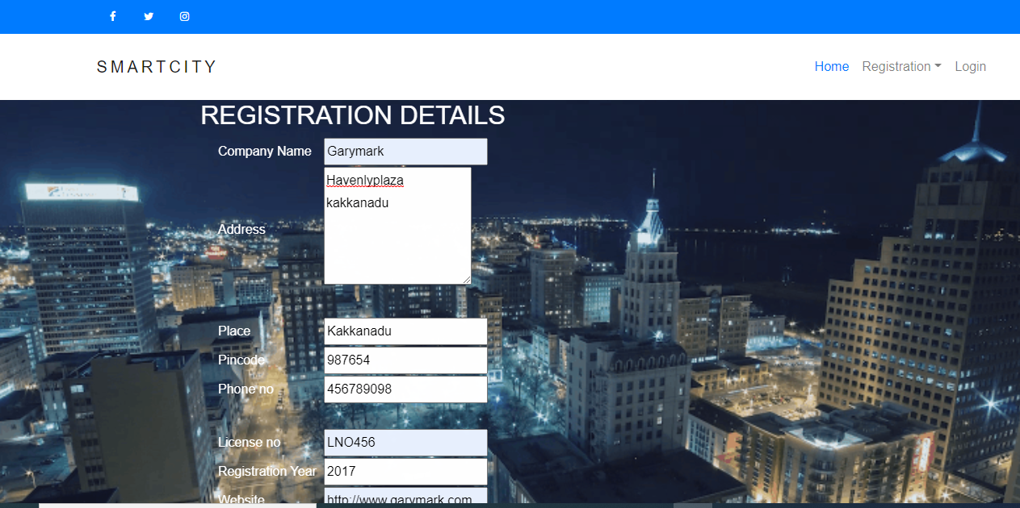

EDUCATION INSTITUTION REGISTRATION

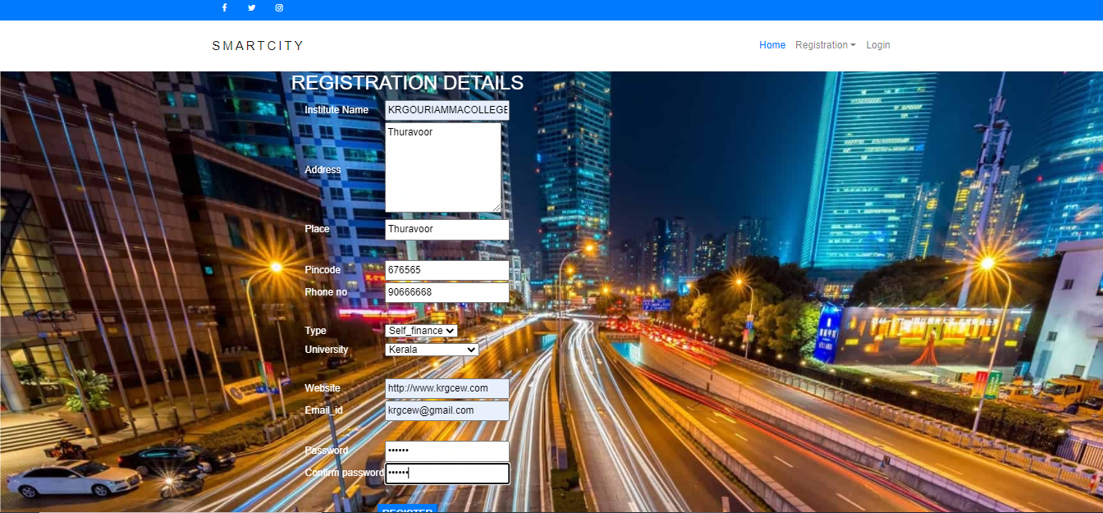

LOGIN

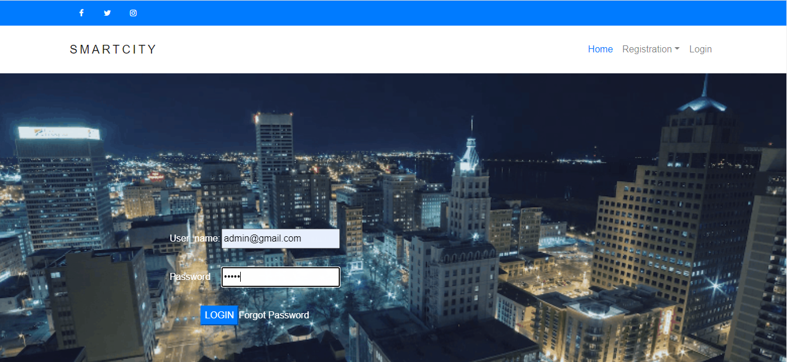

ADMIN HOME

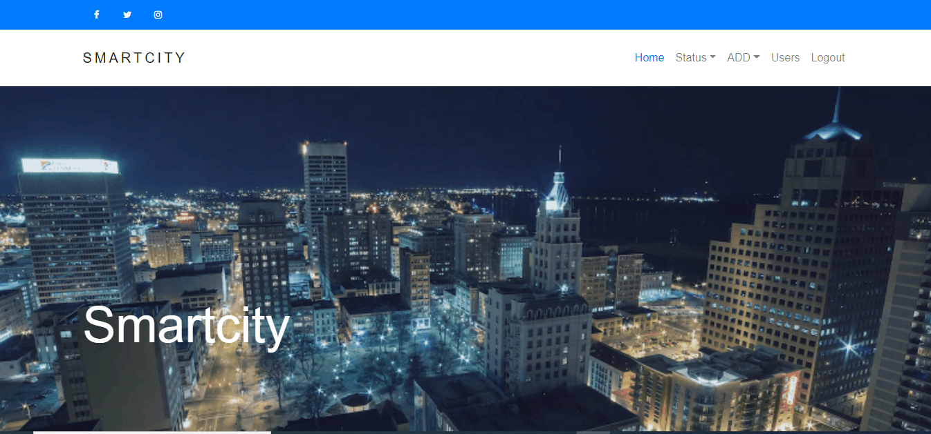

BANK DETAILS

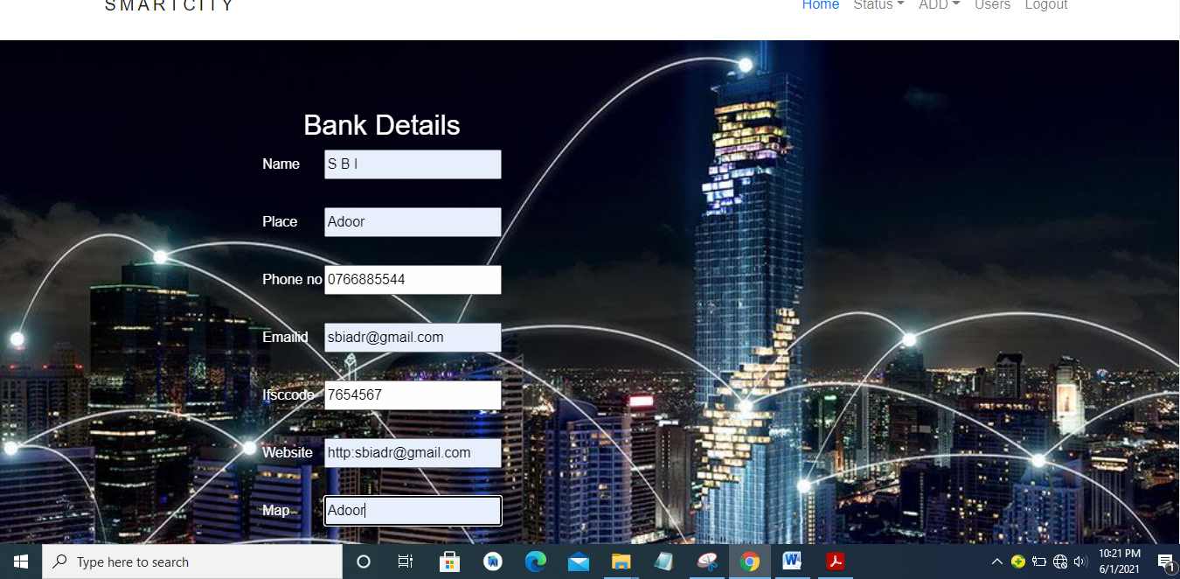

HOSPITAL FORM

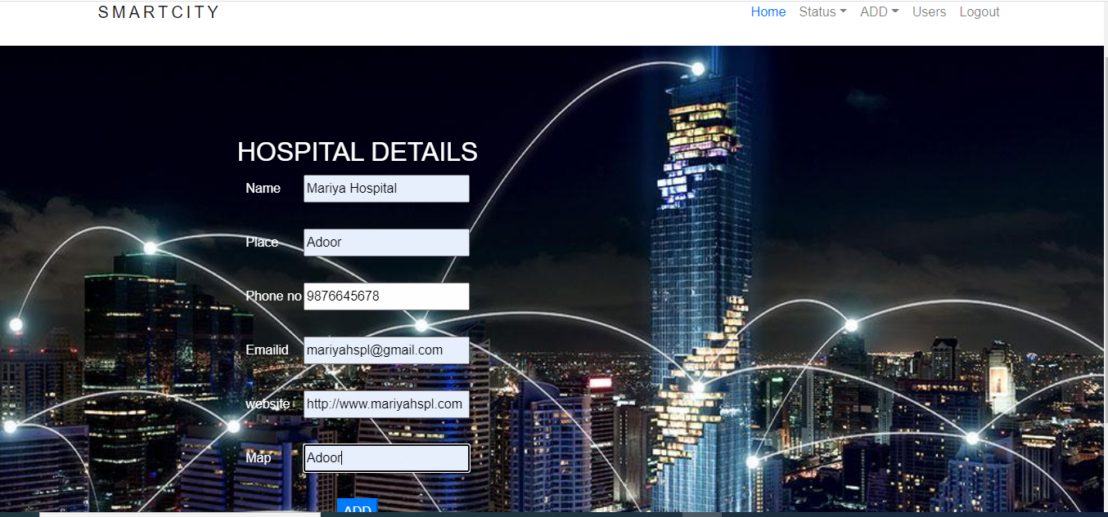

VIEW USERS

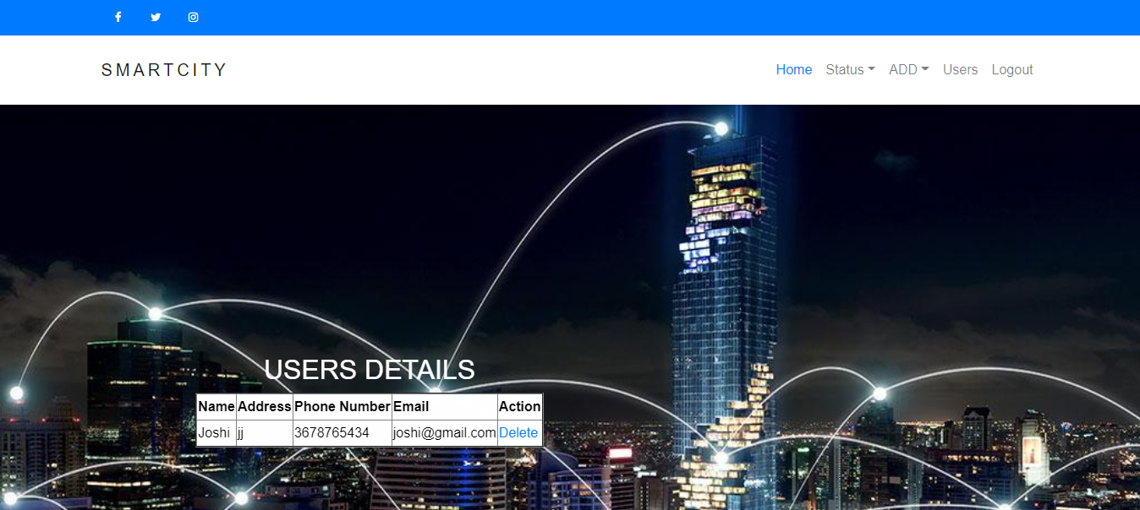

USER HOME

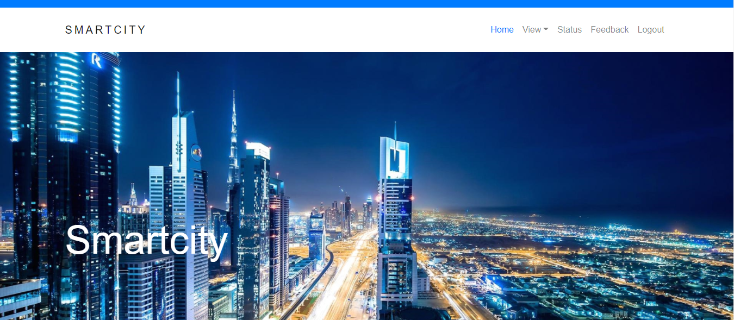

FEEDBACK

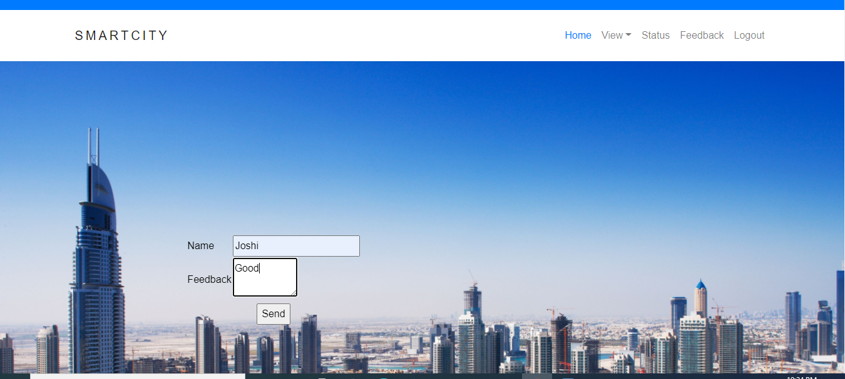

VIEW HOSPITAL  
